**EventExamplesApp:**

**App.js:**

import React, { useState } from 'react';

function App() {

  const [counter, setCounter] = useState(0);

  const [amount, setAmount] = useState("");

  const [currency, setCurrency] = useState("");

  const handleClick = () => {

    setCounter(counter + 1);

    alert("Hello! Member!");

  };

  const handleClick1 = () => {

    setCounter(counter - 1);

    alert("Hello! Member!");

  };

  const welcome = () => {

    alert("Welcome");

  };

  const click = () => {

    alert("I was clicked");

  };

  const convertor = () => {

    const amt = parseFloat(amount);

    if (isNaN(amt) || amt <= 0) {

      alert("Please enter a valid positive number for Amount");

      return;

    }

    const currencyLower = currency.trim().toLowerCase();

    const rates = {

      euro: 0.0095,

      usd: 0.012,

      gbp: 0.0082,

    };

    if (!rates[currencyLower]) {

      alert("Currency not supported. Please enter Euro, USD or GBP");

      return;

    }

    const convertedAmount = amt * rates[currencyLower];

    alert(`Converting to ${currency} Amount is ${convertedAmount.toFixed(2)}`);

  };

  return (

    <div>

      <h2>{counter}</h2>

      <button onClick={handleClick}>Increment</button><br /><br />

      <button onClick={handleClick1}>Decrement</button><br /><br />

      <button onClick={welcome}>Say Welcome</button><br /><br />

      <button onClick={click}>Click on me</button>

      <h1 style={{ color: "green" }}>Currency Convertor!!!</h1>

      <div>

        <label>Amount:</label>

        <input

          type="text"

          value={amount}

          onChange={(e) => setAmount(e.target.value)}

        />

        <br /><br />

        <label>Currency:</label>

        <input

          type="text"

          value={currency}

          onChange={(e) => setCurrency(e.target.value)}

        />

        <br /><br />

        <button onClick={convertor}>Submit</button>

      </div>

    </div>

  );

}

export default App;

**OUTPUT:**

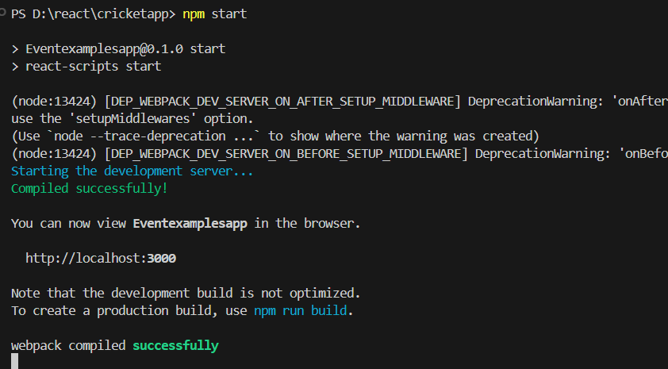

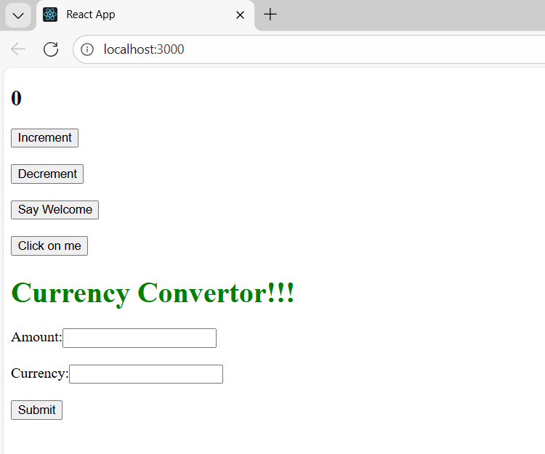

**Increment:**

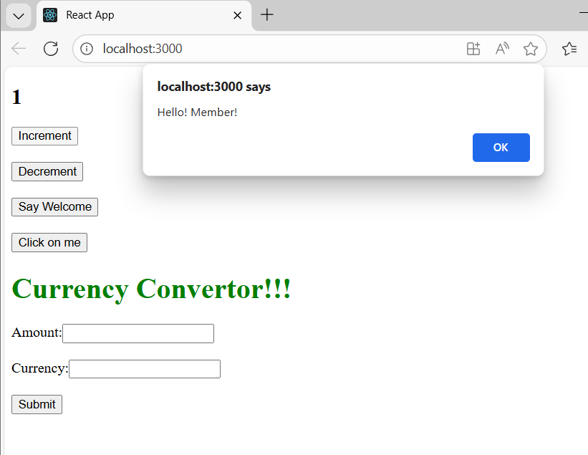

**Decrement:**

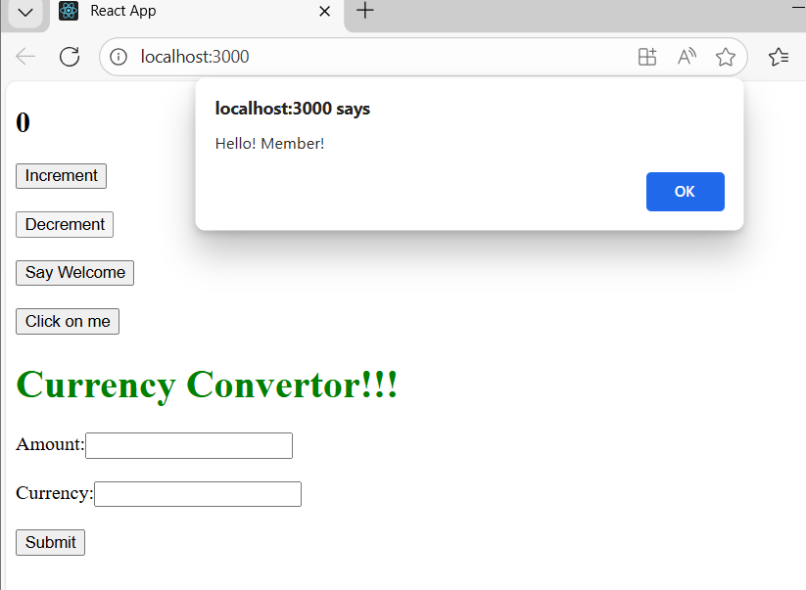

**Say Welcome:**

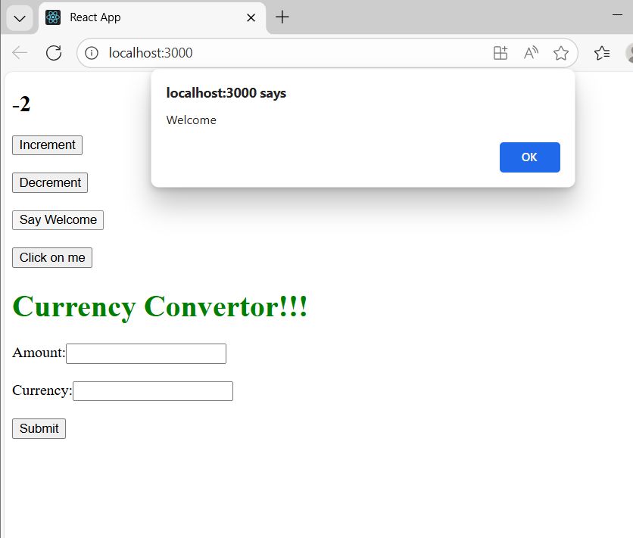

**Click on me:**

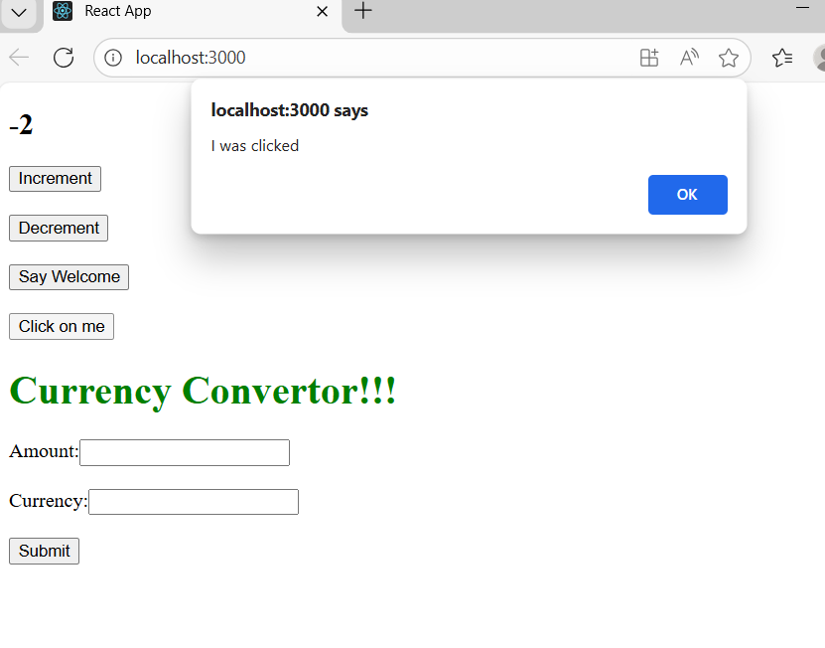

**Currency Conversion:**

